**Chapter 02: LIGHT**

**2/ Interference of Light Waves**

1. A viewing screen is separated from a double-lit source by 1.2 m. The distance between the two slits is 0.030 mm. The second-order bright fringe is 4.5 cm from the center line.

(a) Determine the wavelength of the light.

(b) Calculate the distance between adjacent bright fringes.

1. A light source emits visible light of two wavelengths: 430 nm and 510 nm. The source is used in a double-slit interference experiment in which L = 1.5 m and d = 0.025 mm. Find the separation distance between the third order bright fringes.

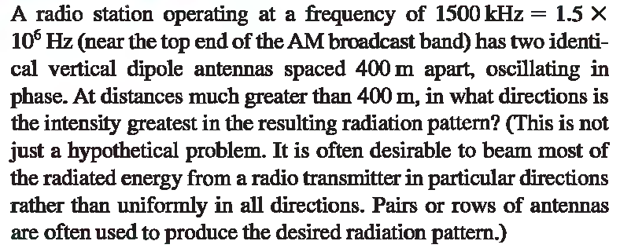

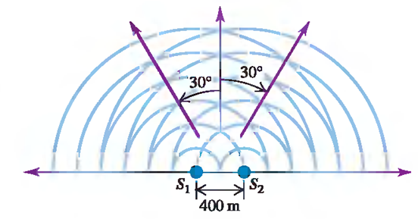

1. A black text on a white background

   Description automatically generatedA diagram of a circle with arrows and lines

   Description automatically generated
2. Calculate the minimum thickness of a soap-bubble (n = 1.33) film that results in constructive interference in the reflected light if the film is illuminated with light whose wavelength in free space is  = 600 nm.
3. A thin, wedge-shaped film of refractive index *n* is illuminated with monochromatic light of wavelength, as illustrated in the figure. Describe the interference pattern observed for this case.
4. Suppose the two glass plates in the figure are two microscope slides 10.0 cm long. At one end they are in contact; at the other end they are separated by a piece of paper 0.0200 mm thick. What is the spacing of the interference fringes seen by reflection? Is the fringe at the line of contact bright or dark? Assume monochromatic light with a wavelength in air of λ = 500nm.
5. Suppose the two glass plates in the figure are two microscope slides 10.0 cm long. At one end they are in contact; at the other end they are separated by a piece of paper 0.0200 mm thick. What is the spacing of the interference fringes seen by reflection? Is the fringe at the line of contact bright or dark? Assume monochromatic light with a wavelength in air of λ = 500nm. Suppose the upper of the two plates is a plastic material with n = 1.40, the wedge is filled with a silicone grease having n = 1.50, and the bottom plate is a dense flint glass with n = 1.60. What happens now?

**3. Light Diffraction**

1. Light of wavelength 580 nm is incident on a slit having a width of 0.300 mm. The viewing screen is 2.00 m from the slit. Find the positions of the first dark fringes and the width of the central bright fringe.
2. You pass 633-nm laser light through a narrow slit and observe the diffraction pattern on a screen 6.0 m away. You find that the distance on the screen between the centers of the first minima outside the central bright fringe is 32 mm. How wide is the slit?

1. Find the ratio of the intensities of the secondary maxima to the intensity of the central maximum for the single-slit Fraunhofer diffraction pattern.
2. The wavelengths of the visible spectrum are approximately 400 nm (violet) to 700 nm (red). Find the angular width of the first-order visible spectrum produced by a plane grating with 600 slits per millimeter when white light falls normally on the grating.
3. Monochromatic light from a helium-neon laser ( λ = 632.8 nm) is incident normally on a diffraction grating containing 6 000 lines per centimeter. Find the angles at which the first order, second-order, and third-order maxima are observed.
4. Monochromatic light with wavelength 620 nm passes through a circular aperture with diameter 7.4 μm. The resulting diffraction pattern is observed on a screen that is 4.5 m from the aperture. What is the diameter of the Airy disk on the screen?
5. You direct a beam of x rays with wavelength 0.154 nm at certain planes of a silicon crystal. As you increase the angle of incidence from zero, you find the first strong interference maximum from these planes when the beam makes an angle of 34.5o with the planes.

**(a)** How far apart are the planes?

**(b)** Other interference maxima from these planes at larger angles?

**4. POLARIZATION OF LIGHT WAVES**

1. If the incident unpolarized light has intensity I0, find the intensities transmitted by the first and second polarizers if the angle between the axes of the two filters is 30°.

**6. Reflection and Refraction**

1. In the figure, material *a* is water and material is a glass with index of refraction 1.52. If the incident ray makes an angle of 600 with the normal, find the directions of the reflected and refracted rays.

1. The wavelength of the red light from a helium-neon laser is 633 μm in air but 474 μm in the aqueous humor inside your eye-ball. Calculate the index of refraction of the aqueous humor and the speed and frequency of the light in this substance.
2. Light traveling in water strikes a glass plate at an angle of incidence of 53.00; part of the beam is reflected and part is refracted. If the reflected and refracted portions make an angle of 90.00 with each other, what is the index of refraction of the glass?
3. A ray of light traveling with speed *c* leaves point 1 shown in the figure and is reflected to point 2. The ray strikes the reflecting surface a horizontal distance x from point

(a) What is the time *t* required for the light to travel from 1 to 2?

(b) When does this time reaches its minimum value?

**7. Mirrors**

1. Assume that a certain spherical mirror has a focal length of 10.0 cm. Locate and describe the image for object distances of

(a) 25.0 cm,

(b) 10.0 cm, and

(c) 5.00 cm.

1. A woman who is 1.5 m tall is located 3.0 m from an antishoplifting mirror. The focal length of the mirror is 0.25 m. Find the position of her image and the magnification.

**8. Thin Lenses**

1. A diverging lens has a focal length of 20.0 cm. An object 2.00 cm tall is placed 30.0 cm in front of the lens. Locate the image. Determine both the magnification and the height of the image.
2. A converging lens of focal length 10.0 cm forms an image of each of three objects placed (a) 30.0 cm, (b) 10.0 cm, and (c) 5.00 cm in front of the lens. In each case, find the image distance and describe the image.
3. A diverging lens has a focal length of 20.0 cm. An object 2.00 cm tall is placed 30.0 cm in front of the lens. Locate the image. Determine both the magnification and the height of the image.
4. An object 8.0 cm high is placed 12.0 cm to the left of a converging lens of focal length 8.0 cm. A second converging lens of focal length 6.0 cm is placed 36.0 cm to the right of the first lens. Both lenses have the same optic axis. Find the position, size, and orientation of the image produced by the two lenses in combination.
5. The eyepiece of a refracting telescope has a focal length of 9.00 cm. The distance between objective and eyepiece is 1.80 m, and the final image is at infinity. What is the angular magnification of the telescope?